**West Coast Collaborative**

**Specialist Mathematics Units 3 & 4**

**Test 2 2018**

**Functions & Sketching Graphs**

**Task weighting: 7%**

**Calculator Free Section**

**Name: __________________________ Score: _____ / 22**

**Time Allowed**: 22 minutes, under test conditions

**Materials Allowed**: SCSA formula booklet

**Materials required:** Standard items: Pens (blue/black preferred), pencil, sharpener, correction fluid/tape,

eraser, ruler, highlighters.

**Instructions:** Where a question or part of a question is worth more than 2 marks sufficient working to justify your solution is required. Simplify answers where possible.

**Question 1. (3 marks)**

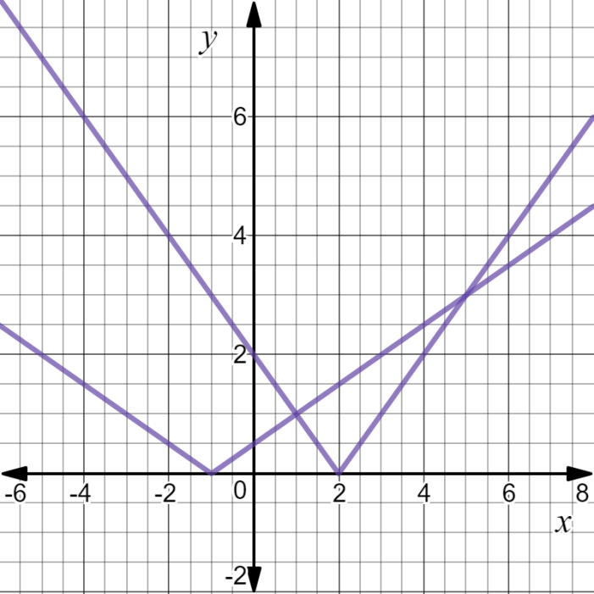Use the diagram opposite to assist you to solve:

$0.5\left|x+1\right|≤2$

$2-x=0.5\left|x+1\right|$

$\left|2-x\right|>0.5\left|x+1\right|$

**Question 2. (4 marks)**

Consider the nature of the graph of $y=$ $\frac{x^{2}+x-6}{x^{3}+4x^{2}+3x}$. Describe the effect on the y values of the

graph as

1. x tends to $-∞$
2. x tends to ${-3}^{+}$
3. x tends to $-1^{-}$
4. x tends to $-2^{-}$

**Question 3. (3 marks)**

The graph of $y=\left|x-3\right|-2$ is shown below. Find $b$ and $c such that the solution to the$ equation

$\left|x-3\right|-2=-\left|x+b\right|+c$ is $x=-2, 9$.

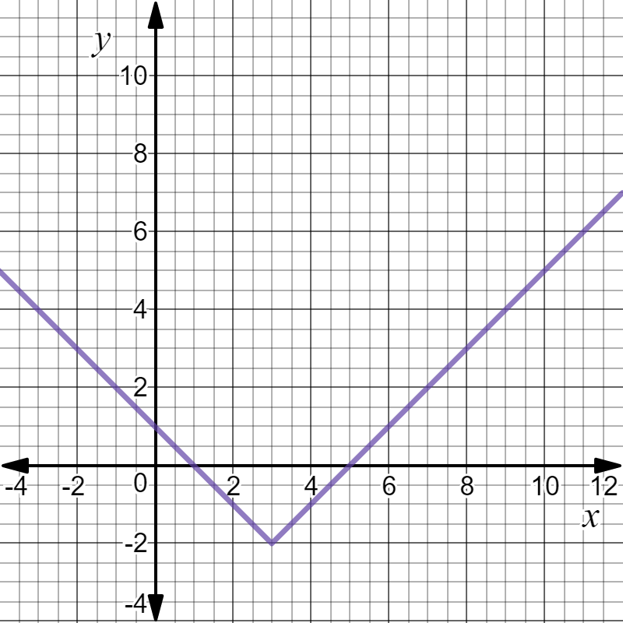

**Question 4. (4 marks)**

If $f\left(x\right)=3-$ $\frac{2}{x}$ determine

1. $f^{-1}(4)$ (2)

1. The value(s) of x such that $f^{-1}(x)=f(x)$. (2)

**Question 5. (4 marks)**

If $f\left(x\right)=x^{2}+2$ and $g\left(x\right)=$ $\frac{1}{x+3}$ find the natural domain and corresponding range for

1. fog(x) (2)

1. gof(x) (2)

**Question 6. (4 marks)**

Find an expression for the inverse function of $p$ where $p\left(x\right)=4+$ $\frac{1}{2+x}$ and state the domain and range of $p^{-1}$.

**End of Section One**

**This page has intentionally been left blank.**

You may use this space to extend your working on a particular question or questions. Remember to number each extension.

**West Coast Collaborative**

**Specialist Mathematics Units 3 & 4**

**Test 2 2018**

**Functions & Sketching Graphs**

**Task weighting: 7%**

**Calculator Assumed Section**

**Name: __________________________ Score: _____ / 33**

**Time Allowed**: 33 minutes, under test conditions

**Materials Allowed**: SCSA formula booklet, Calculators and 1 page of A4 notes, written on both sides

**Materials required:** Standard items: Pens (blue/black preferred), pencil, sharpener, correction fluid/tape,

eraser, ruler, highlighters.

**Instructions:** Where a question or part of a question is worth more than 2 marks sufficient working to justify your solution is required. Simplify answers where possible.

**Question 7. (4 marks)**

The graph of $y=f(x)$ is shown below in diagram (a). Show the graph of $y=\left|f(\left|x\right|)\right|$ in diagram (b).

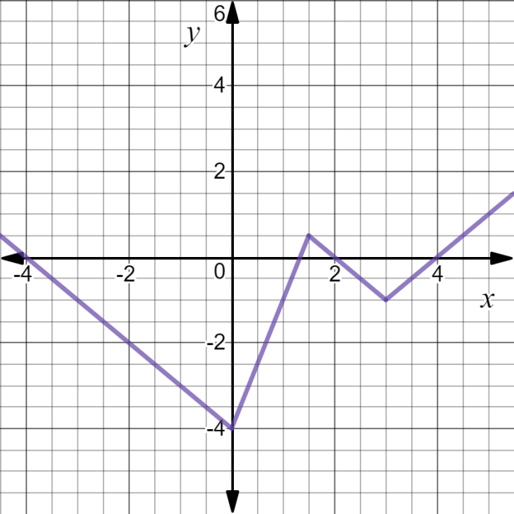(a) (b)

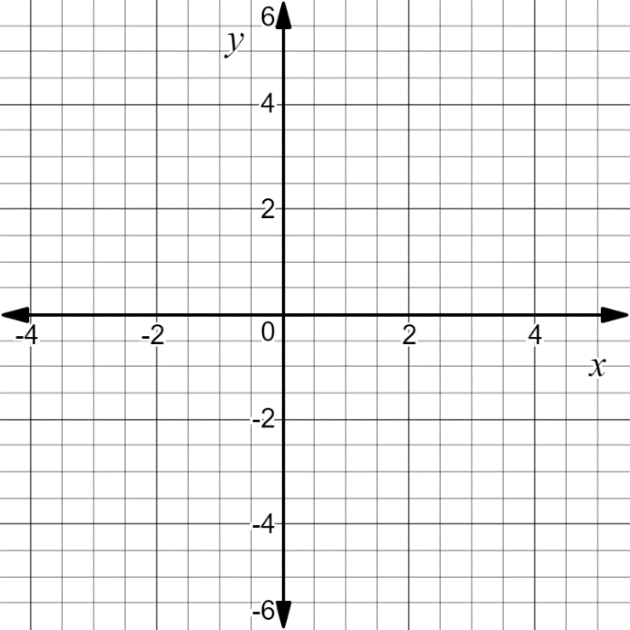

**Question 8. (3 marks)**

Find an expression for the inverse function of $q(x)$ where $q\left(x\right)=5-$ $\frac{1}{2x-3}$ and state its

domain and range.

**Question 9. (4 marks)**

Consider the graph of $y=$ $\frac{4x^{2}+4x}{x^{3}+x^{2}-4x-4}$

1. Locate any asymptotes. (2)

1. Describe any other discontinuities. (2)

**Question 10*.* (6 marks)**

Determine all of the asymptotes for each of the following functions:

1. F(x) = $\frac{x^{2}+2x}{x-1}$ (2)
2. G(x) = $\frac{x^{2}-4}{x(x+2)}$ (2)

1. H(x) = $\frac{{2x}^{2}+1}{(x-1)(x+2)}$ (2)

**Question 11. (5 marks)**

The graph of $y=h(x)$ is shown below. It has asymptotes at $x=0, x=4, y=$ $\frac{2}{5}$. On the next set of axes draw the graph of $y=$ $\frac{1}{h(x)}$, clearly showing any roots and asymptotes.

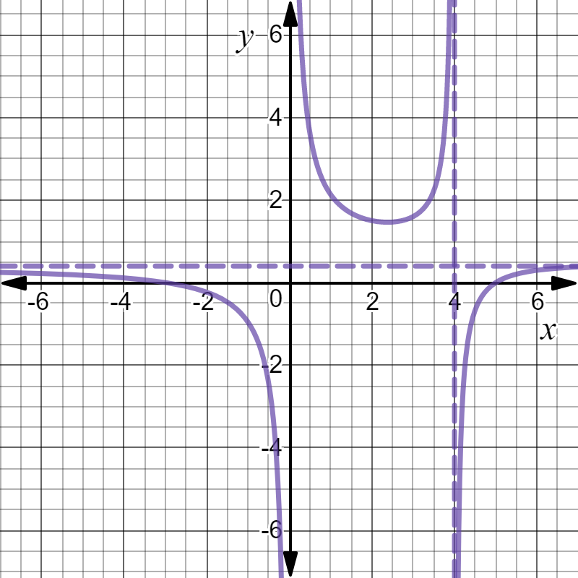

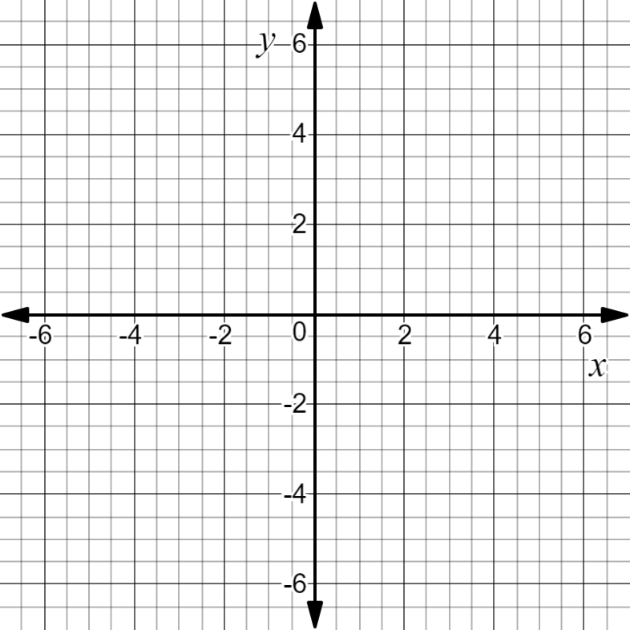

**Question 12. (7 marks)**

The graph of $g\left(x\right)=$ $\frac{(x-6)(x+1)}{x-3}$, $x<3$ has asymptotes $x=3 and y=x-2$ as is shown below:

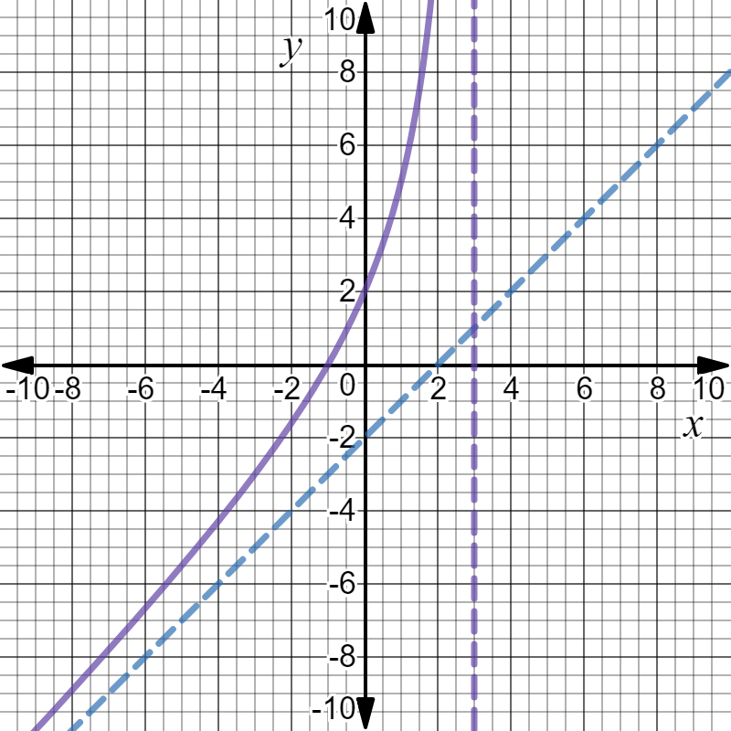

1. Explain why $g$ has an inverse function $g^{-1}$ and find $g^{-1}(0)$. (2)
2. Sketch the graph of $y=g^{-1}(x)$ on the same set of axes above. Include any

asymptotes in your sketch. (3)

1. Solve for $x ,$ $g^{-1}\left(x\right)=1.5$. (2)

**Question 13. (4 marks)**

Given that $p\left(x\right)=x^{2}-1$ and $q\left(x\right)=$ $\frac{3}{x}$ state the natural domain and the corresponding

range of each of the following functions:

1. $poq(x)$ (2)
2. $qop(x)$ (2)

**End of Test Paper**

**This page has intentionally been left blank.**

You may use this space to extend your working on a particular question or questions. Remember to number each extension.